“We must measure what can be measured, and make measurable what cannot be measured.”
- Galileo Galilei, 1610
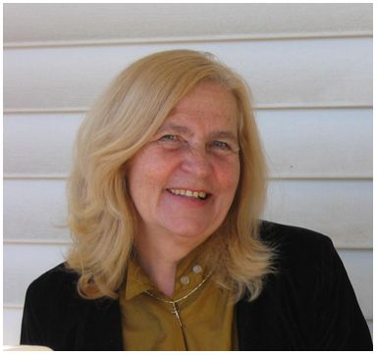 | Kerekes Judit, Ed.D.  Asst. Prof. of Math Education  Department of Education  College of Staten Island (CSI)  City University of New York  2800 Victory Boulevard, 3S-  Staten Island, NY 10314  phone: 718-982-4112  e-mail: kerekes@mail.csi.cuny.edu  Dr. Kerekes's Recent Publications  Publications and Presentations | 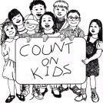
PROFESSIONAL LEADERSHIP | RESEARCH SITES | SYLLABI
American Hungarian Collegiums  President, 2007-present  http://amhuncol.com/  American Hungarian Schools at American Hungarian School Educators Association, USA  Division Chair of American Hungarian Schools section, 2004 - 2006  http://hungaria.org/hal/ahea/ | CSI Library Catalog  CSI Databases  ERIC on the Web  Lessons Plans from ERIC  New York Public Library Catalogs  New York Public Library Databases | FALL 2005  - EDE 303 Syllabus  - EDD 630 Syllabus  - EDE 642 Syllabus  SPRING 2009  - EDE 642 7575 Syllabus  - EDE 642 9542 Syllabus  - EDD 630 & EDE 631 Syllabus
HELPFUL INFORMATION SITES  Department of Education (CSI)  College of Staten Island  City University of New York  NYC Department of Education  US Department of Education |  | ACTIVITIES  Bolyai Conference at CSI  Bolyai Conference images  Bolyai Conference presentations  American Hungarian Collegium  Collegium homepage  2008 Collegium photos
384 x 362 - 25k - jpg - www.library.csi.cuny.edu/.../JuditWeb2009.jpg
Image may be subject to copyright.
Below is the image at: www.library.csi.cuny.edu/~kerekes/

